**1. Introduction to Computer hardware: Physical identification of major components of a computer system such as mother board, RAM modules, daughter cards, bus slots, SMPS, internal storage devices, interfacing ports**.

**Procedure:**

**What is Computer Hardware?**

Computer hardware is a hardware part of a computer system. In simple words, only those parts of the computer system which we can see or touch are called computer hardware.

Hardware is an important part of our computer system without which the computer is incomplete. You cannot use a computer without hardware and without hardware, there cannot be a computer system or construction.

# **1. Mouse**

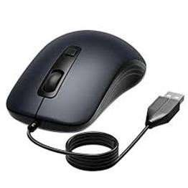

A mouse is a hardware input device that is used to move the cursor or pointer on computer screens. It can also be used to run computer programs, select items in a graphical user interface, and manipulate objects in the computer world. Some common examples of how it can be used are clicking on buttons, scrolling up and down the screen, selecting files, opening folders, and so on.

# **2. Keyboard**

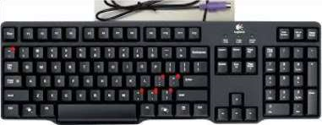

A keyboard is an input device that you use to enter data into a computer. It's also called the input device for your computer. Keyboards are used with PCs, laptops, tablets, and other devices. There are many different types of keyboards, but the most common one is the QWERTY keyboard. A QWERTY keyboard has all the letters in alphabetical order on it. This is different from some other types of keyboards, like Dvorak or Colemak keyboards. For example, these keyboards have keys arranged differently than what you’re used to seeing on a QWERTY keyboard. And that means that typing on these keyboards will feel like typing in another language at first! But don’t worry - once you get accustomed to it, it feels natural!

**3. Monitor**

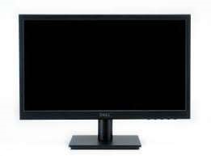

Personal computers use a monitor to display data, run the software, and interact with the user. A monitor is an electronic visual display that connects to your computer or laptop. It is used for displaying images, text, videos, games, web pages, and more. Monitors are available in different sizes depending on the needs of the person using them. The most common types of monitors are CRT (cathode ray tube), LCD (liquid crystal display), and LED (light-emitting diode).

# **4. Motherboard**

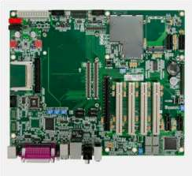

The motherboard is the backbone of our computer system. It's the central processing unit or CPU. It connects all the other components, like memory and graphics card, to the power supply. The motherboard is where all the wires are plugged in and it's also where you place your RAM, which is your computer's working memory. The motherboard is what makes one machine different from another.

Motherboards are made up of tiny transistors that control the flow of electricity through copper tracks on their surface. These transistors are called Integrated Circuits or ICs for short.

# **5. CPU ( Central Processing Unit )**

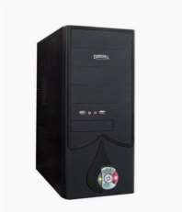

A CPU, or central processing unit, is the brain of a computer. The CPU processes information and runs programs. It functions as a control unit that executes programs according to instructions in its program memory. The CPU contains elements such as registers, an arithmetic logic unit (ALU), and control logic for sequencing instructions.

# **6. RAM Memory**

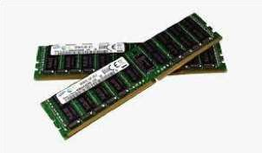

A computer's RAM is a type of computer memory that stores information so the CPU can access it directly. Computer systems use main memory to store both data and programs. The more RAM you have, the more data your system can process at one time. This will lead to more efficient operations on your computer, which translates into better performance for the user.

# **7. ROM Memory**

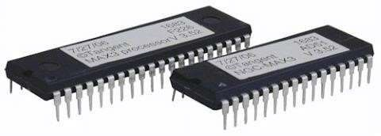

ROM stands for a type of memory chip that can be read from but not written to. In other words, it's a form of data storage that can't be changed after being programmed. It's sometimes called "non-volatile" memory because the stored information will remain even when not powered up or in use. ROM is often used to store a computer's basic start-up instructions and certain types of data, such as your car's on-board computer system and a calculator's data tables.

**8. Hard Disk Drive**

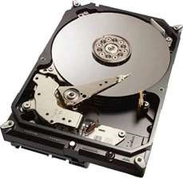

A hard disk drive is a piece of hardware inside a computer that stores information.It's used to store software and data in a safe place, which can be accessed when needed. With magnetic storage, there are no moving parts - unlike a CD or DVD player in which you need to move a disk in order to access data. You can think of it as "a closet" where all your stuff is stored safely. As long as you have power, you can get to your things when you need them.

# **9. Optical Drive**

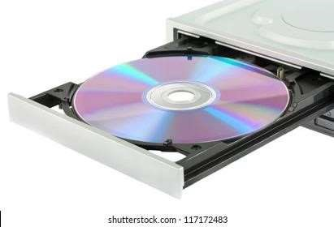

Optical Drives are used in PCs to read and write CDs and DVDs. The optical drive reads the data from the disc, which can then be transformed into a digital file that is readable by the computer. This makes it easy to backup files, play music or movies, or copy data from one disc to another. The term "CD" refers to Compact Discs, which are the most common type of optical drive on modern computers. They are often used for installing software on your computer, moving data between computers, or writing new programs.

# **10. Power Supply**

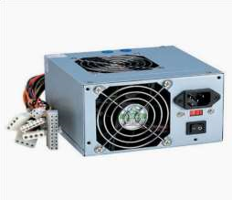

A power supply is an electrical appliance that provides the necessary power to operate a computer.Computers are powered by electricity, and the power supply converts the alternating current (AC) from the electric outlet into direct current (DC). The power supply in a computer can be an internal or external component.

**2. Install latest version of Ubuntu on a virtualbox**

**Procedure:**

1. Download and Virtualbox Windows 10 Installation

2. Ubuntu ISO download

3. Install Virtualbox

4. Create an Ubuntu VM

5. Install Ubuntu on Virtualbox Windows 10

6. Install Virtualbox Guest Additions

**Download and Virtualbox Windows 10 Installation**

1. Install Ubuntu on VirtualBox

2. HowTo Install Ubuntu On VirtualBox?

2.1. Open VirtualBox

2.2. Click on “New” to create a virtual machine

2.3. Enter Name for your Virtual Machine

2.4. Select “Linux” Operating System from“Type”

2.5. Click “Next”

2.6. Enter amount of memory (RAM) =1024 MBand click “Next”

2.7. Click “Create” to create hard drive

2.8. Click “Next”

2.9. Click “Next”

2.10. Enter Size of Virtual Hard Drive= 20 GBand Click “Create”

2.11. Select Virtual Machine

2.12. Click on “Start” to start the virtual machine

2.13. Select disk file source

2.14 Afters electing the OS file to be installed click “Open”

2.15. Click “Start”

2.16. Click “Ok”

2.17. Click “Install Ubuntu” 20MCA136 NETWORKING & SYSTEM ADMINISTRATION LAB DEPT. OF COMPUTER APPLICATIONS ST.JOSEPH’S COLLEGE OF ENGINEERING AND TECHNOLOGY, PALAI 7

2.18. Click “Continue”

2.19. Click “Install Now”

2.20. Click “Continue”

2.21. Select location and click “Continue”

2.22. Select keyboard layout & click “Continue”

2.23. Fill all the details and Click “Continue”

2.24. Now the installation process will start and installation window will appear

2.25. Click “Restart Now”

2.26. When the system will get restarted the following message will appear. Press “Enter”

2.27. Close the pop-up messages by clicking on the Close (×) button

3. Steps To Maximize The Size Of Ubuntu Desktop

3.1. Go to “Devices”

3.2. Click “Insert Guest Additions CD Image…”

3.3. Click “Run”

3.4. Click “Authenticate”

3.5. Press “Enter”

3.6. Now “Restart” your system for the changes to be applied.

3.7. After the system gets restarted. Go to “View”

3.8. Click “Switch to Full screen”

**Output Screenshots:**

**STEP 1**: Installing Virtual Box.

1. **Starting pop-up window for the installation**

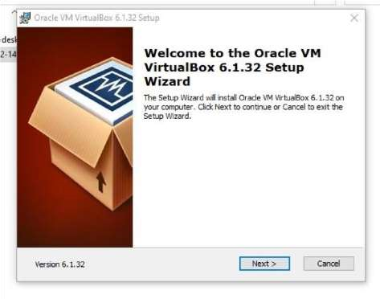

1. Custom setup window to select the features you want and select installation location .

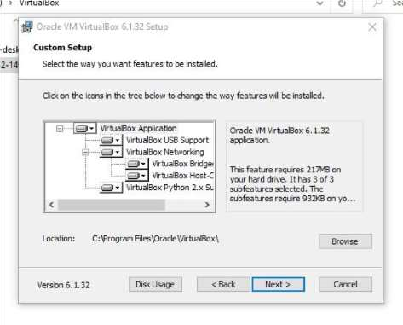

1. Custom setup window to choose from the option below.

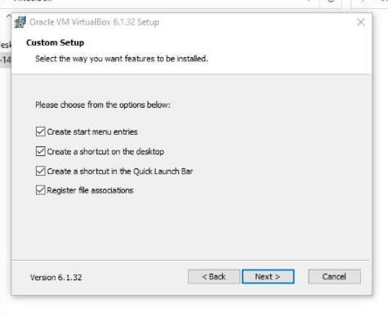

1. Custom setup window to confirm the installation.

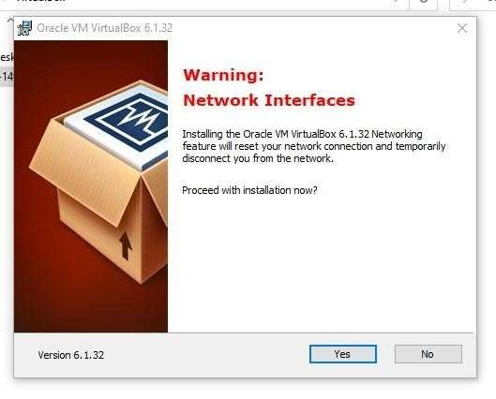

1. Custom setup window to install the virtual box with the install button.

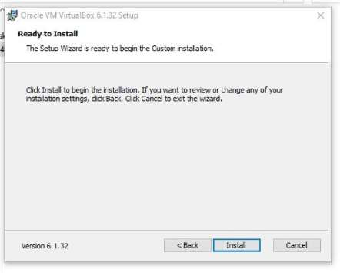

1. Installation box showing the installation status.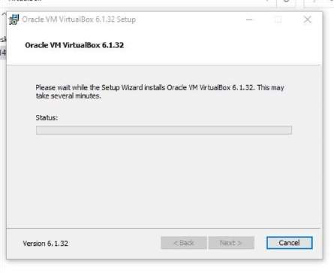
2. Installation complete pop-up windows with the finish button .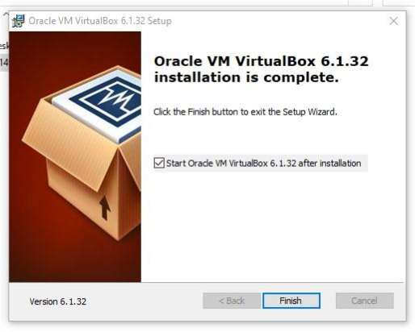

**STEP 2:** Setup the Ubuntu Instance in the VM Virtual Box.

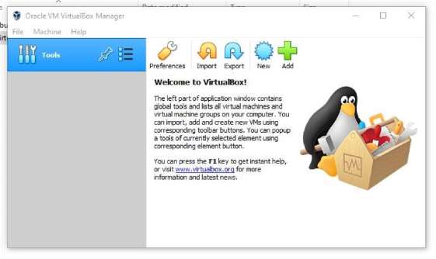

1. After selecting the NEW button to create the Ubuntu instance, the pop-up window to enter & select the name, type and version of the OS.

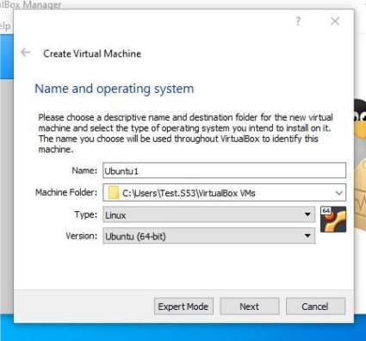

1. Choose the main memory size for the OS.

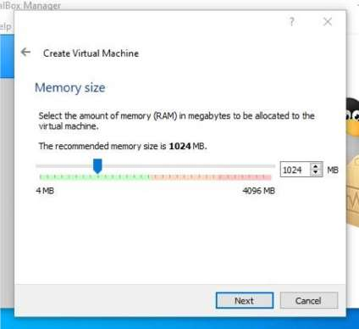

1. Option to add a virtual hard disk to the new machine instance.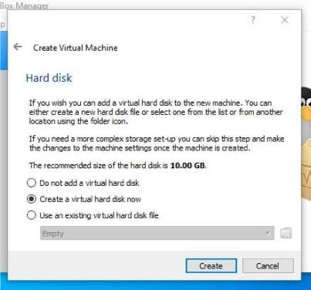
2. Option to choose the type of new virtual hard disk for new instance of OS.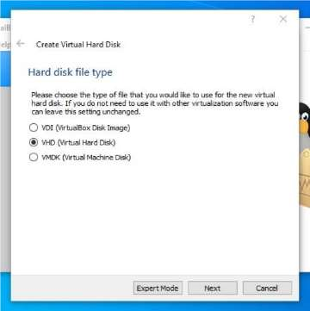
3. Options to choose the methods of accessing the physical hard disk space for the new instance from the existing hard disk . 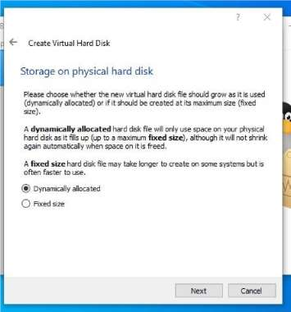
4. Panel to select the size of the virtual disk in megabytes and location and name of the

instance and final submit to create the instance of OS.

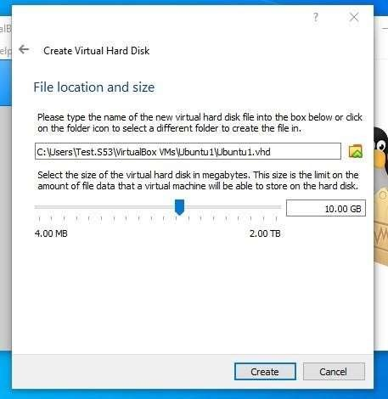

1. The newly created OS instance and at the left side of the application.

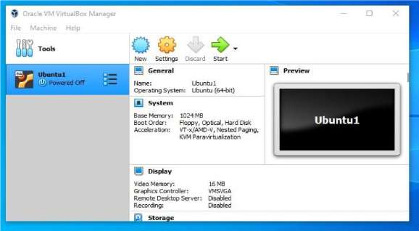

1. Settings the configurations of the instance created and adding the ISO image file of the OS correspondingly and Selecting the ISO image file from the local device.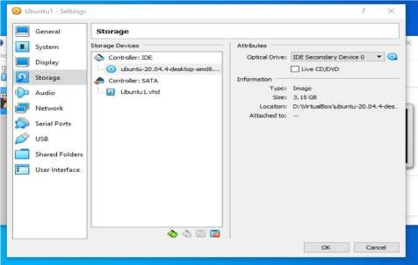

**STEP 3:** Installation of the Ubuntu OS within the newly created instance.

1. Running the new OS instance and selecting the “Install Ubuntu” to install the loaded ISO file.

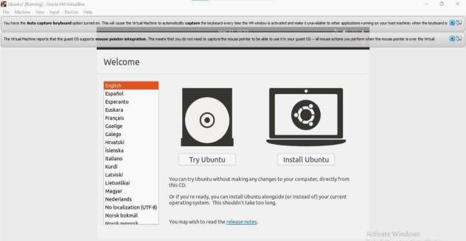

1. Selecting the language for install the ubuntu OS.

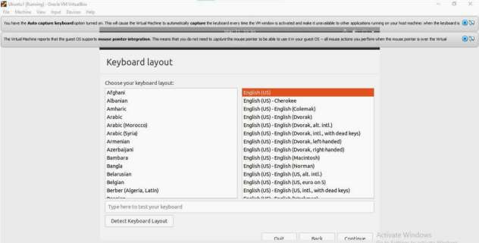

1. Selection of other installation along & within with the installation of ubuntu.

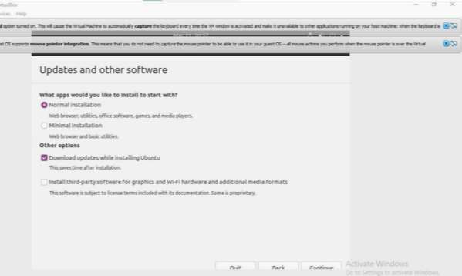

1. Selecting the disk partitioning allocation options from the given below.

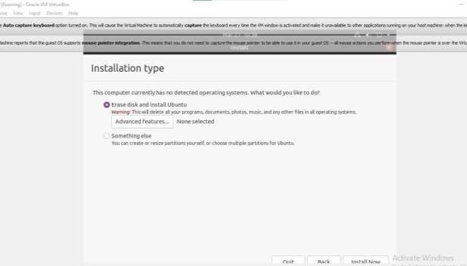

1. Selecting the geographical location for the time/location.

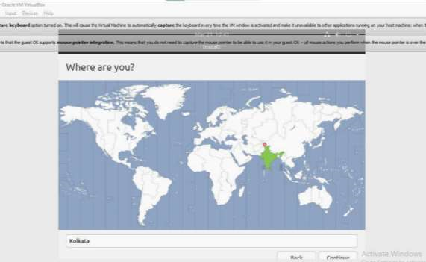

1. Entering the name, username & password for the account to sign in to the ubuntu OS after installation.

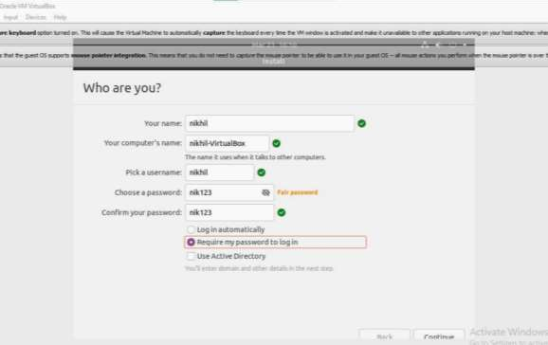

1. Installing the ubuntu OS in the instance, extracting the ubuntu ISO file, setting configurations, setting the various software within, etc.

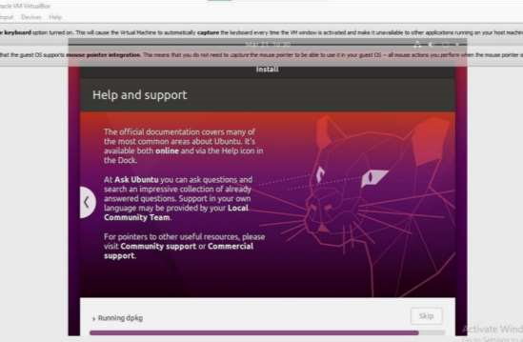

1. Restarting the OS instance to finalize the installation.

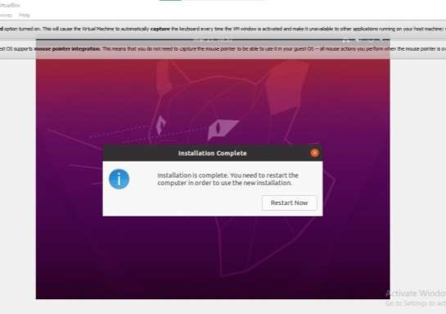

1. Signing in and visiting the home screen of the ubuntu OS using the previously registered username & password.

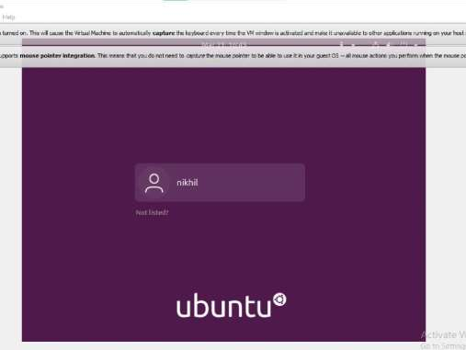

**Output:**

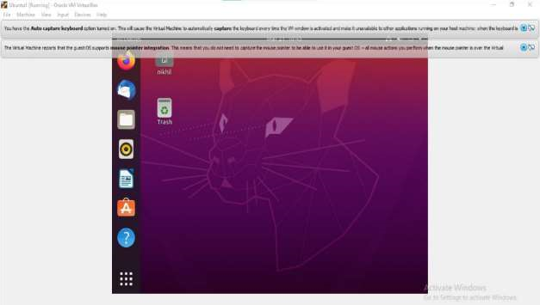

**3. Study of a terminal based text editor such as Vim or Gedit, Basic Linux commands: - familiarity with following commands/operations expected**

# **Procedure**

* **Pwd:** This command is used to display the location of the current working directory.

Syntax :-$ pwd

**Output:**

Screenshot from 2024-04-17 11-14-20.png

* **Mkdir:** This command is used to create a new directory under any directory.

Syntax :-$ mkdir<directory name>

**Output:**

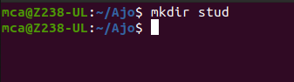

* **ls:** This command is used to display a list of content of directory.

Syntax :-$ ls

**Output:**

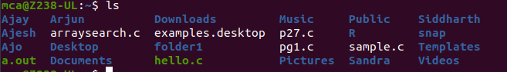

* **Man:**This command is used to display the user manual of any command that we can run on the terminal.

Syntax :-$ man <command name>

**Output:**

Screenshot from 2024-04-17 11-18-22.png

* **Cd:**This command is used to change the current directory.

Syntax :-$ cd <directory name>

**Output:**

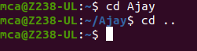

* **cd.. :** This command is used to move to the parent directory of current directory, or the directory one level up from the current directory.
* **cd –:**This command is used to switch back to previous directory we were working earlier.
* **cat > filename:** This command is used to view the contents in a file.

Syntax :-$ cat > filename.txt

**Output:**

Screenshot from 2024-04-17 11-19-55.png

* **cat>>filename**:This command is used to add contents to an existing file.

Syntax :-$ cat >> filename.txt

**Output:**

Screenshot from 2024-04-17 11-20-40.png

* **cat filename1 > filename2**:This command is used to copy the content from one file to another file.

Syntax :-$ cat filename1 > filename2

**Output:**

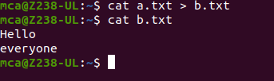

* **read** :This command is used to read the content of a line to a variable.

Syntax :-$ read variablename

* **Find**:This command is used to display contents of particular directory.

Syntax :-$ find filename.txt

* **grep** :This command will let you search through all the text in a given file.

Syntax :-$ grep word filename.txt

**Output:**

* **grep -i :**command used for a case insensitive search

Syntax: $ grep -i filename.txt

* **grep -v :**command used for inverted search.

Syntax: $ grep -v filename.txt

* **grep -A1:**command used to display line after the result.

Syntax: $ grep -A1 filename.txt

* **grep -B1:**command used to display line before the result.

Syntax: $ grep -B1 filename.txt

* **grep -C1:**command used to display line before and after the result.

Syntax: $ grep -C1 filename.txt **wc -word count:**This command is used for counting purpose which is used to find the number of lines,the number of words,the number of characters and the number of bytes.

* **wc -l** (count number of lines)
* **wc -w** (count number of words)
* **wc -c** (count number of characters)
* **wc -m** (count number of bytes) Syntax :- $ wc -l filename.txt

$ wc -w filename.txt

$ wc -c filename.txt

$ wc -m filename.txt

**Output :**

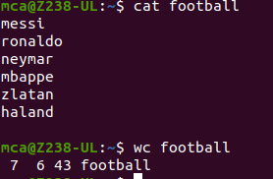

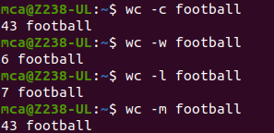

* **df** :This command is used to get a report on system disc space usage.

Syntax :-$ df filename.txt

**Output:**

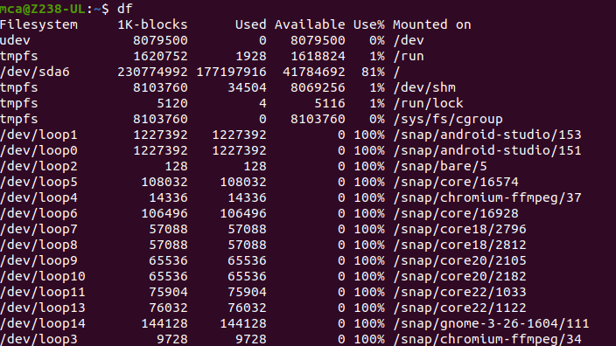

* **df -m** :This command is used to see the report in mega bytes.

Syntax :$ def -m filename.txt

* **cut -d**:This command is used to cut and display the content based on the delimiter given.

Syntax :-$ cut –d delimiter –fieldnumber filename

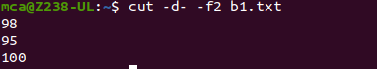

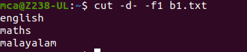

* **cut -b:**This command is used tocut and display the content based on the specified byte number.

Syntax :-$ cut –b bytenumber filename

**Output:**

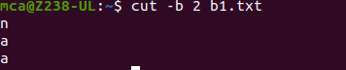

* **cut --complement -c:**This command is used to erase the specified character and display the remaining content of the file.

Syntax :-$ cut --complement –c character number filename.txt

**Output :**

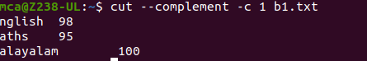

* **Paste:**This command is used to paste the contents from the specified file.

Syntax :-$ paste filename

**Output:**

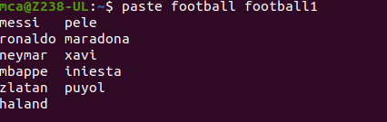

* **More:**This command is used to view the text files in the command prompt, displaying one screen at a time in case the file is large.

Syntax :-$ more filename

* **Cp**:This command is used to copy the contents from an existing file to a new file.

Syntax :-$ cpexisting_filenamenew_filename

**Output :**

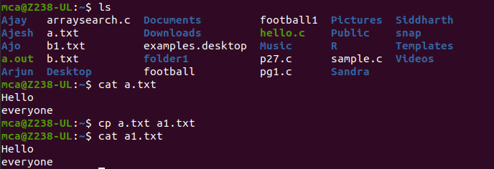

* **Mv**:This command is used to move an existing file or directory from one location to another.

Syntax :-$ mv filename directory_name

**Output:**

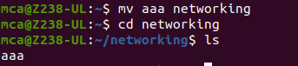

* **Head**:This command is used to display the first 10 lines of the file by default. Syntax :-$ head filename

**Output:**

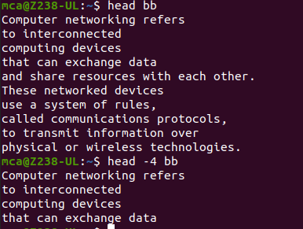

* **head -number**:This command is used to display the lines of the file to the specified number from head.
* **Tail:**This command is used to display the last 10 lines of the file by default.

Syntax :-$ tail filename

**Output:**

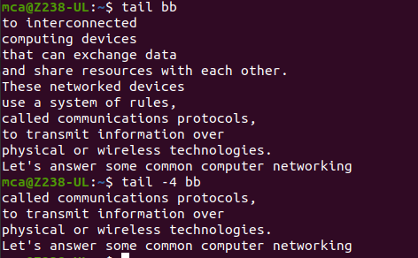

* **tail -number**:This command is used to display the lines of the file to the specified number from tail.

* **sudo useradd** :This command is used to add new user.

Syntax :-$ sudo useradd username

**Output:**

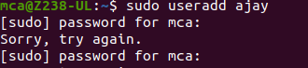

* **sudo passwd** :This command is used to add password to the user.

Syntax :-$ sudo passwd username

* **sudo usermod** :This command is used to add members.

Syntax :-$sudo usermod -G groupname username **delete**

* **sudo userdel username -** used to delete user.
* **sudo groupdel groupname -** used to delete group name.

# Syntax :-$ sudo userdel username

* **sudo groupdel groupname**  **chmod** :This command is used change directory permission of files.
* chmod +rwx
* chmod -wx
* chmod +rwx

Syntax :- $ chmod +rwx filename

$ chmod -wx filename

$ chmod -rwx filename

**Output :**

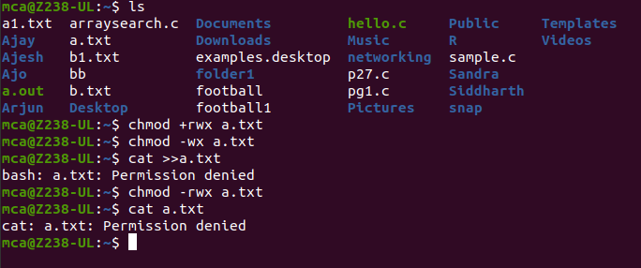

* **chown:**This command is used to give ownership to user .

Syntax :- $ sudo chown username filename

**Output :**

Screenshot from 2024-04-17 11-58-24.png

* **Ssh**:This command is used to provide a secure encrypted connection between two hosts over an insecure network.

Syntax :- $ ssh mca@ipaddress

**Output:**

Screenshot from 2024-04-17 12-04-26.png